**AIM:** To find the GCD of two numbers using 8085 processor.

**Expt:no:12**

**ALGORITHM**:

1. Load the first number (num1) into the B register.

2. Load the second number (num2) into the C register.

3. Compare the values in the B and C registers using the CMP instruction.

4. If the values are equal (Z flag is set), the GCD has been found and is stored in the B and C registers.

5. If the value in the B register is greater (CY flag is set), subtract the value in the C register from the B register using the SUB instruction.

6. If the value in the C register is greater (CY flag is not set), subtract the value in the B register from the C register using the SUB instruction.

7. Repeat steps 3-6 until the values in the B and C registers are equal (Z flag is set).

8. The GCD will be stored in the B and C registers.

**INPUT**:

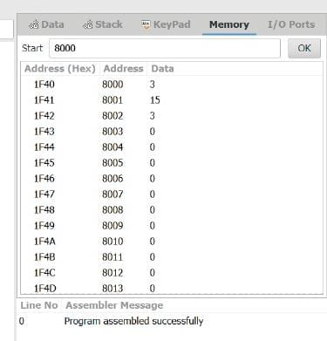

OUTPUT:

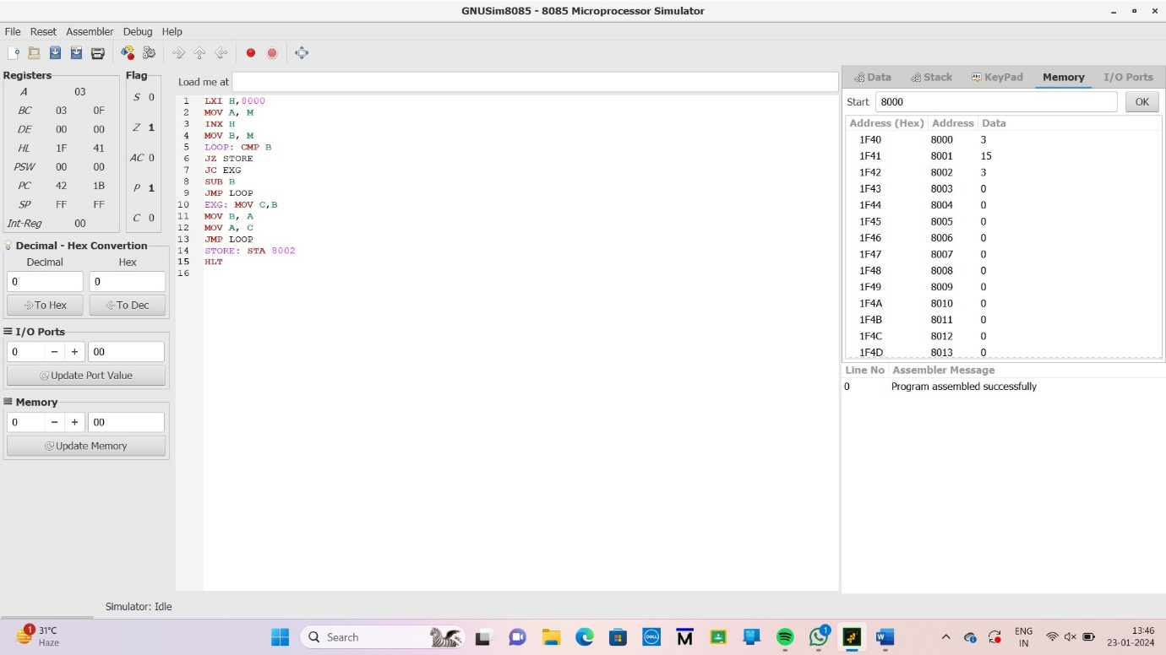

**RESULT**: Thus the program was implemented successfully using 8085 processor